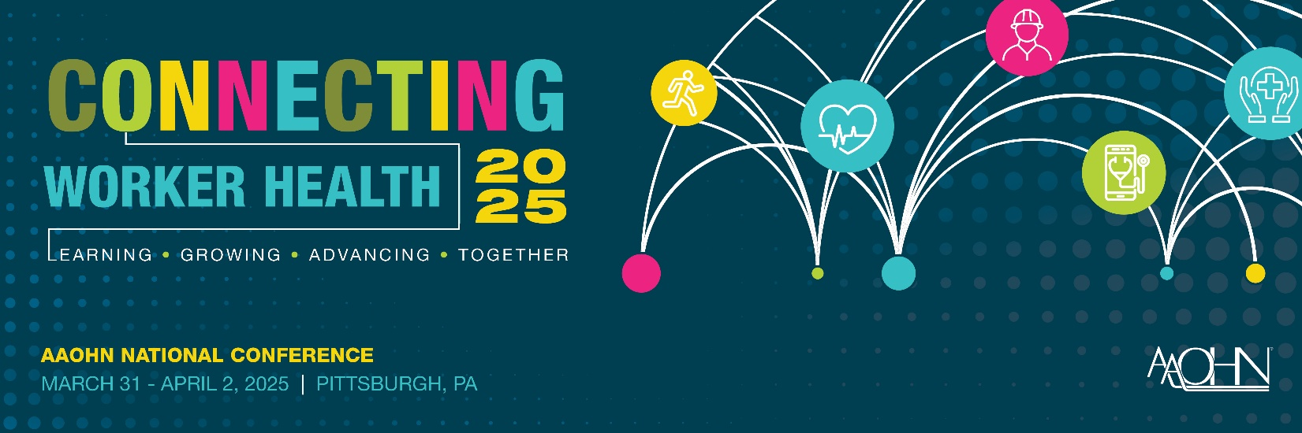

The American Association of Occupational Health Nurses is pleased to announce the 2025 Annual National Conference to be held March 31- April 2, 2025 in Pittsburgh, PA at the David L. Lawrence Convention Center. We invite professionals to share their expertise and highlight unique nursing challenges in occupational and environmental health nursing.

Session Formats: Concurrent podium (30 or 60 minute options) and poster presentation formats. We welcome lectures, panel sessions or networking sessions with educational learner outcomes. We welcome poster proposals from occupational health nurses, faculty, students or others in all occupational health nursing topic areas.

2025 Topic suggestions:

- Business Issues / Return on Investment
- Chronic Condition Management /Accommodations/ Coaching
- Clinical Practice- Updates to best practices or Refresher courses
- Clinic First Responder training- or re-training
- Case Management
- Diversity Equity and Inclusion
- Emergent Practice – Marijuana use and the workplace Contingent Workforce/Migrant Health/ Remote Work/ Changes in the Delivery of care, Primary Care/Onsite Clinics
- Emergency Preparedness- Violence / Active Shooter / Disaster Planning
- Emerging and Re-emerging Diseases
- Epidemiology
- Ergonomics
- Fit for Duty
- Generational Employee Care/Screening and Retaining Older Workers
- Global Occupational Health
- Health Promotion/Wellness/Total Worker Health
- Hearing Conservation
- Interdisciplinary Health and Safety Programs and Topics
- Legal and Ethical Issues
- Management and Leadership
- Medical Surveillance Programs
- Musculoskeletal
- Nursing Professional Development
- OSHA Updates
- Remote Work
- Research/Evidence-based Practice
- Safety & Environmental Health (including communications, regulations, LEED certified workplaces, collaborative workplaces)
- Toxicology / Chemical Use
- Workers Compensation

Proposals must:
- demonstrate a concise statement of significance of the topic;
- be relevant to the anticipated audience needs for education at intermediate or advanced levels of practice;
- focus on leading-edge subjects of interest to those working in any occupational health setting;
- be appropriate for both the OHN RN and the APRN/NP audience; offer sufficient detail to demonstrate the application of the topic for presentation; and
- pertain to occupational health nursing research, evidence/solution-based clinical practice, disability management, safety, health promotion, leadership, business/management and policy initiatives.

Guidelines for Submission:
- Login to your AAOHN account. * All submitters must have a Member or Guest Account.
- If you are creating a new account, follow the prompts to create a profile.
- You will need to select MY AAOHN and then Community for Competitions to submit your proposal at AAOHN24
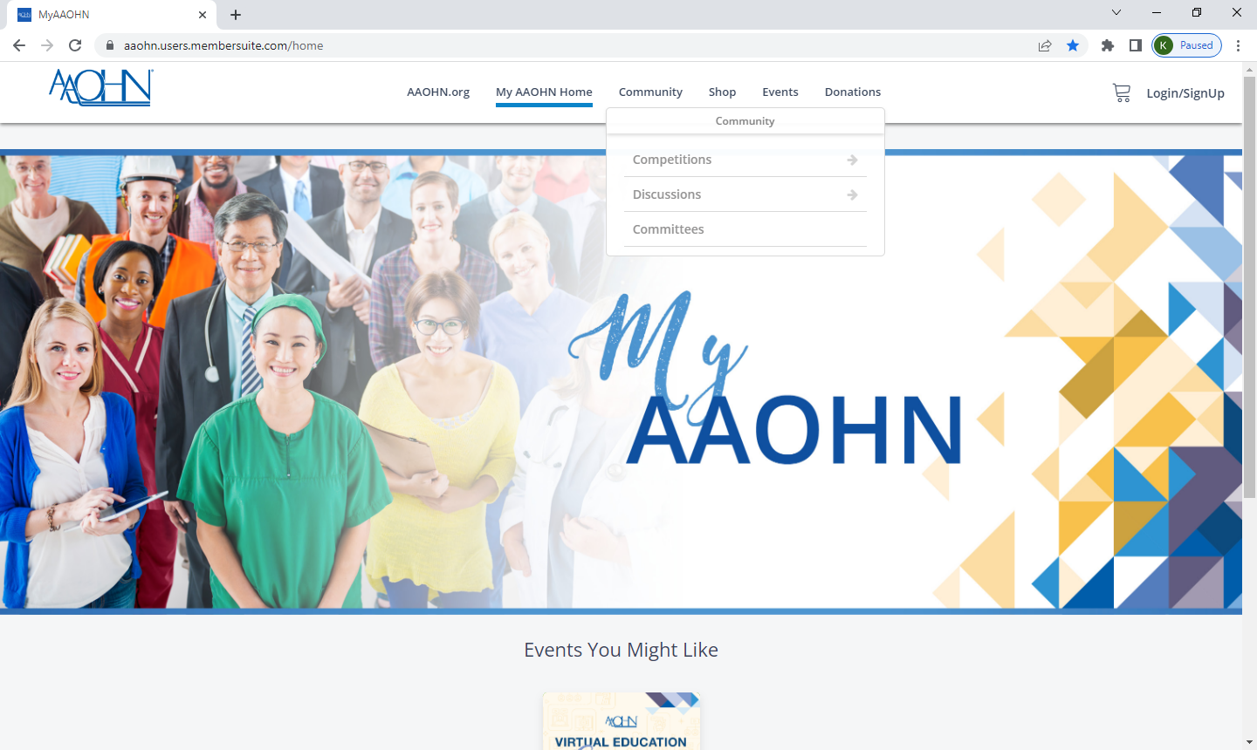

- Select View Open Competitions to select the Annual Conference 2024 Proposals. Then Select the Annual Conference 2024 Proposal Submission
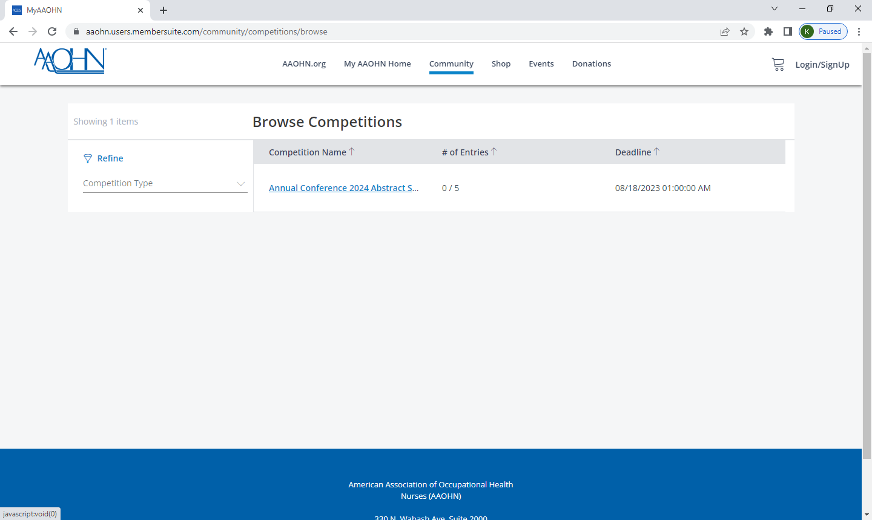

- You may review your submission or submit additional proposals through the deadline
- Select Type- Use the Dropdown to select Podium or Poster
- On your entry, you will enter your Session Title twice, see the screenshot below from 2024. Please note to look for 2025.
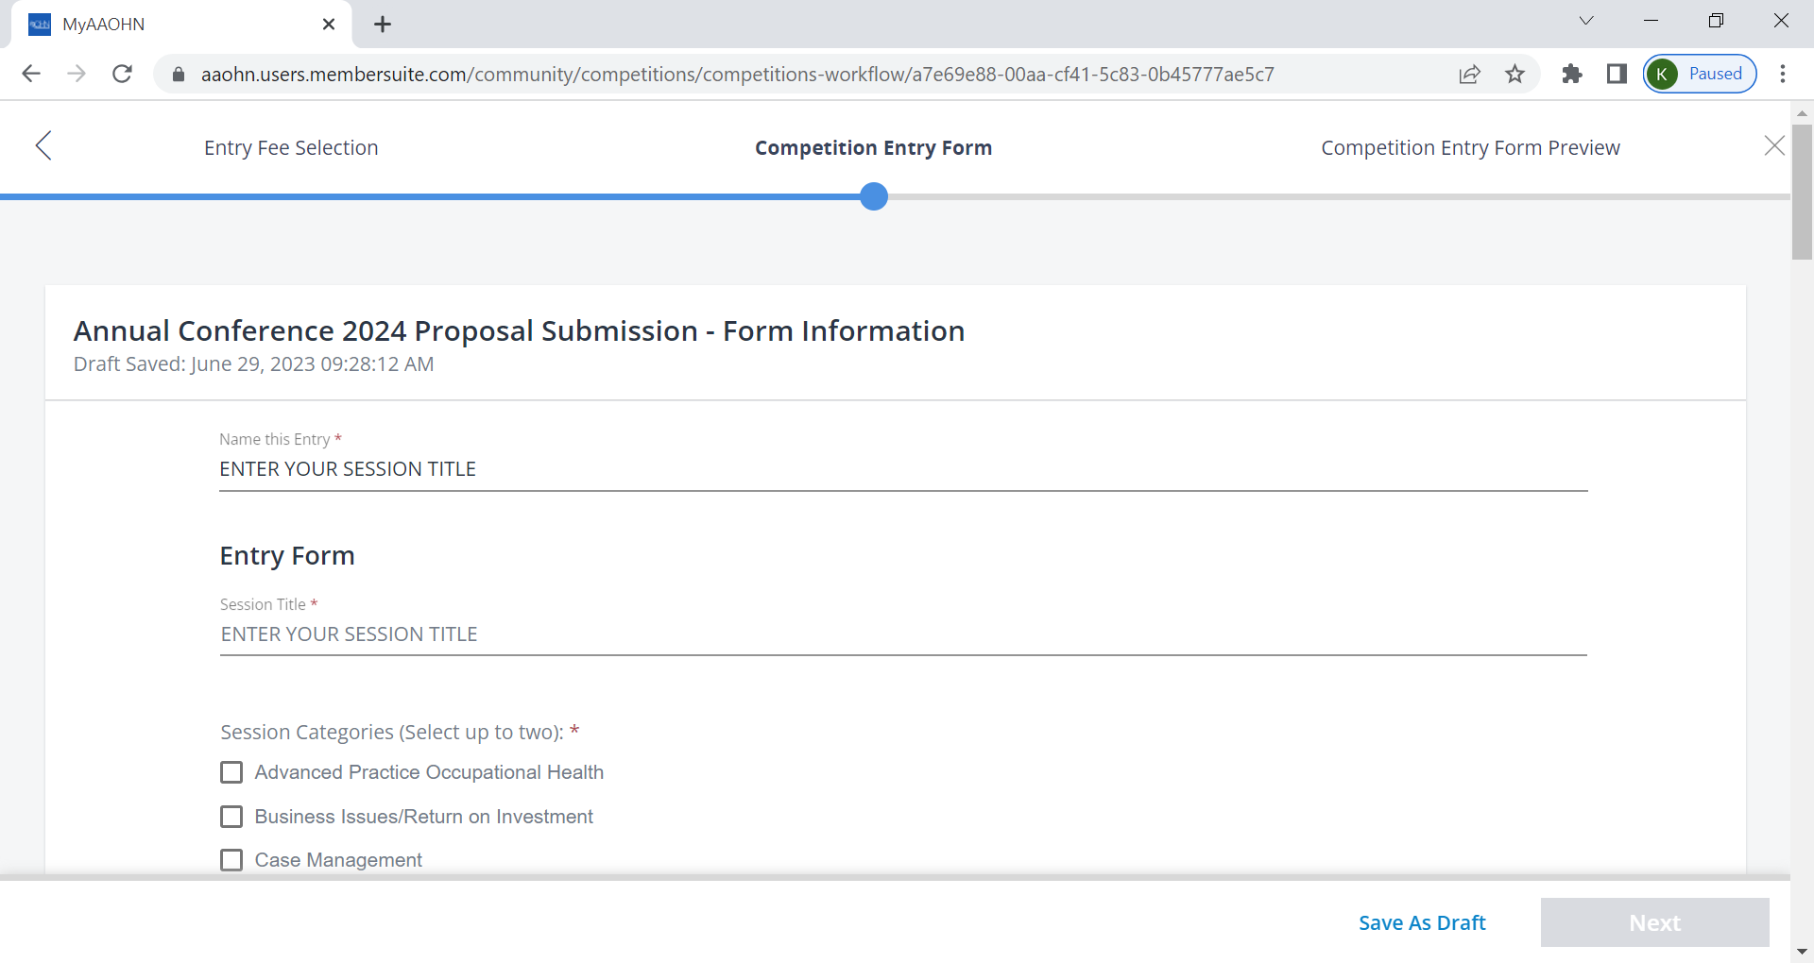

Deadline:
Conference Podium Session submissions will close August 25, 2024
Conference Poster Session submissions will close September 8, 2024

Author proposals are welcome and will undergo an open, competitive peer-review process for selection. Keep in mind that proposals will score highest on topics that reflect leading-edge, evidence-based, forward-thinking and innovative topics, address mid- and advanced-levels of practice and are appealing to a large number of conference attendees. Proposals that do not show clear and accurate interpretation of implications and recommendations for practice gaps, education, research, and/or policy for one or more of the occupational health nursing subspecialties will not be accepted. Proposals received after the deadline will not be reviewed.

The American Association of Occupational Health Nurses, Inc.’s purpose is to provide evidence-based information with implications for occupational and environmental health nursing. Material presented at the national conference, available on the website, or provided in any printed materials must be evidence-based, of professional quality, and demonstrate an absence of proprietary or prejudicial/biased commentary. Anecdotal observations should be limited in their scope and not presented as proven fact. It is inappropriate to endorse or imply endorsement of any specific product or service. Presentations may be recorded.

For further information or questions, please contact education@aaohn.org .

